Archives of Surgical Research | Syed Zafar Haider Memorial Feature

In Memory of Late Prof Syed Zafar Haider FRCS England
Syed Abul Hasan Kazmi |  |  | SZH Memorial Feature  Corresponding Author:  Dr Syed Abul-Hasan Kazmi,  MBBS (Pb), MCPS (Pak), FRCS (Edinburgh); Email: syedahkazmi@gmail.com  https://doi.org/10.48111/2020.01.01
IMPORTANCE Prof Syed Zafar Haider, an exceptional teacher, trainer, surgeon, orator, leader and above all a great human being has influenced a generation of surgeons in Pakistan over the past 70 years. His belief in quality, systematic surgery and surgical discipline was instrumental in producing a great cohort of people who have or are serving this nation and abroad. His contribution to surgical discipline in Pakistan remains outstanding and on top.

KEYWORDS Mentorship, surgery, Syed Zafar Haider

HOW TO CITE Kazmi AH. In Memory of Late Prof Syed Zafar Haider FRCS England. Archives of Surgical Research. 2020;1(3):1-2. https://doi.org/10.48111/2020.03.01

I
am Syed Abul-Hasan Kazmi. I am at present in Scotland, United Kingdom. I retired a few years ago from the post of a Consultant Surgeon at Ninewells Hospital and Dundee University Medical School.

I had the privilege of being very close to Professor Syed Zafar Haider during the 70s, firstly as a medical student and then as an SHO and registrar in the First Surgical Unit of Nishtar Hospital, Multan along with my two other great colleagues, Dr Hamid Ali Shah as my senior registrar and Azim Khawaja as my SHO. Professor Haider and Hamid Shah taught me how to hold the knife for health and all the important bits and bobs in life that I cherish and carried with me all along.

I feel very honoured that Professor Azim Khawaja and Dr Talat Waseem asked me to write something about a great man who we all hold in high esteem as our mentor and father figure. I am so glad to see his name and picture at the fore front of PETSA that gives a long due credit to a man who pioneered Thyroid Surgery in Pakistan in the days when the whole nation and the system were in the cradle.
Syed Zafar Haider Sahib was born on 27 December 1927 in Lahore. The family’s ancestral home was in Bazaar-e-Hakiman in the Bhaati Gate of Lahore. He belonged to a highly educated family that was settled in Pakpattan as they had their farm land in two villages called Chak Amir Ali Shah and Chak Haider Shah.

His paternal grandfather, Syed Haider Shah, was an officer in the British Army, and maternal grandfather was the fifth Muslim Barrister of India in 1886 and founder of Anjuman-i-Hamayat-i-Islam, the oldest teaching institution of Punjab. Allama Iqbal, our national poet, got his recognition as a poet in his home.
His father Mohammad Shah was a lawyer and held a Master’s degree in English literature. His mother studied English at home along with Persian. His elder brother Abbas Haider was a dentist firstly in De Montmorency Lahore and later he was the pioneer in setting up Dental College at Nishtar, Multan. His younger brother Afzal Haider is an eminent lawyer in Lahore.
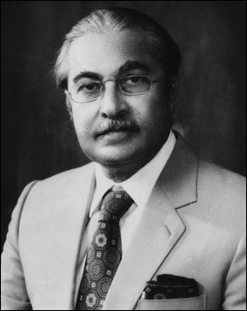

During his early life, Prof. Haider was brought up in an intellectually and culturally stimulating atmosphere. He started his primary school at Pakpattan in 1932. He completed his matriculation in1942 from Government High School, Pakpattan, where he topped his class. He did his FSc from FC College Lahore in 1944. These were the days when Pakistan was in the making.

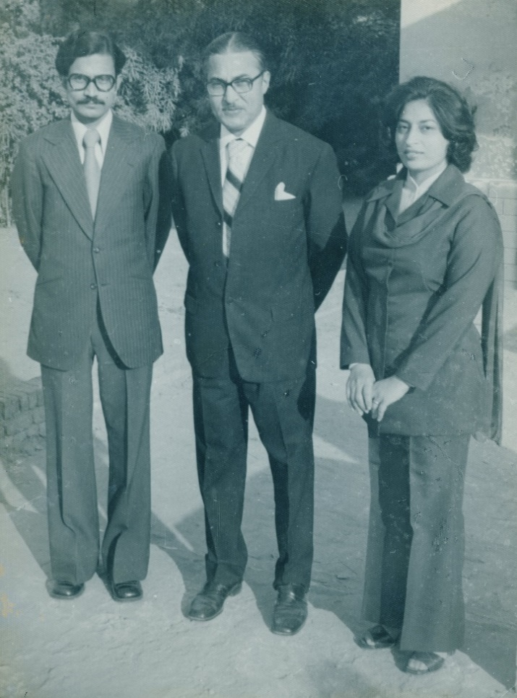

Me with Syed Zafar Haider & Dr Tahira Bokhari - 1978

He joined KE Medical College, Lahore in 1945 and graduated in 1950. He did his first house job in Surgery with Professor Amir-ud-Din who was his teacher and mentor. I always heard a lot of things about him from Zafar Haider Sahib while I worked with him and even after and Prof Azim Khawaja can vouch for that.

In 1952 he moved to England where he got his fellowship from the Royal College of Surgeons of England in 1957. There he worked with very eminent surgeons and professors of that time.

He returned to Pakistan in 1957 as Assistant Professor in Nishtar Medical college, then moved to Services Hospital Lahore in 1962 and to KE as Assistant Professor in 1964. He then moved back to Nishtar in 1966 where he stayed till 1980.
At Nishtar he pioneered Oesophageal and Head & Neck Surgery including Thyroid and carried out the first partial nephrectomy there.

In 1980 he moved to King Edward Medical College, Lahore. At Mayo Hospital he did the first parathyroidectomy in Punjab and made East Surgical ward the centre for Thyroid Surgery doing more than two thousand thyroidectomies.
He retired in 1988. Following this, he continued teaching at KEMC and at Shalimar Hospital Medical School on honorary basis. He also lectured at the College of Physicians and Surgeons, Karachi and served as principal of Islamabad Medical & Dental College. Later he had to stop these activities due to ill health.

Syed Zafar Haider, a handsome man and always immaculately dressed who was self-disciplined, straightforward and forthright with tremendous resilience, who expected the same from his students, younger colleagues and peers. He made concerted efforts to groom his students not only in medicine but in their language, communication skills, mannerism and dress code.

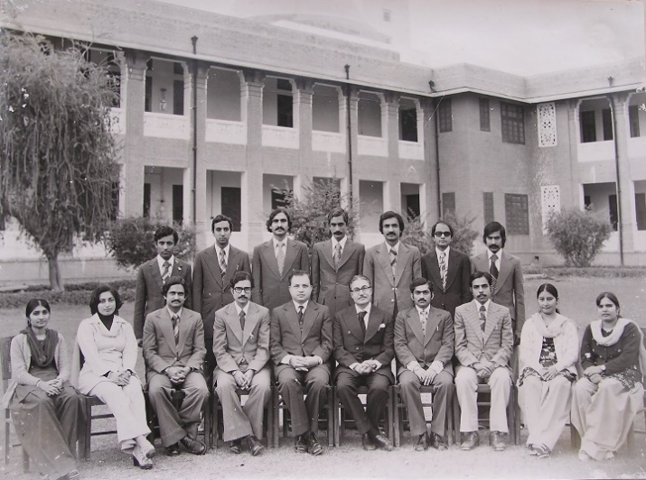

Staff of First Surgical Unit, Nishtar Hospital Multan - 1976

A charismatic speaker, having complete command over language and subject, imparting knowledge was his passion for which he used unique methods. While teaching he spoke in a slow deliberate manner, particularly while stressing on an important point. He would spend his own resources and time to prepare the teaching material such as slides and clinical photographs and surgical pathology specimens to elaborate his lectures. This was when such material was difficult, expensive and time consuming to prepare. I saw this all happening, and I am proud to be part of this.

He was dedicated to his patients and would ensure that no one was treated without proper supervision of seniors and that every patient got the best possible treatment, given the resources.

He married Dr Tahira Bokhari in 1958, who was our Histology teacher in Nishtar and later she moved to King Edward with him. They had three children, two daughters and a son. Zahra the eldest is now Professor of Anatomy and Khadija, though studied Medicine and graduated, branched to Psychiatry specialising in Trauma Therapy.

His son, Ali Haider, got his fellowship in Ophthalmology from the Royal College of Surgeons of Edinburgh. He became an eminent professor, teacher and trainer in Eye Surgery in Lahore and was a great philanthropist. On 18 July 2013, he fell victim to the targeted sectarian violence and was martyred along with his younger son Murtaza.

Their martyrdom was a turning point in the life of Syed Zafar Haider. After this he went down in health and emotions, and passed away on 3rd August 2017, grief stricken for having lived to see the loss of his only son and a grandson at the hands of the nation he had dedicated his life to.

Syed Zafar Haider strived and struggled for Pakistan during the independence movement and it was for the love of his country that after FRCS he opted to return to Pakistan and serve the nation. He also made his son, Ali, do the same. An optimist for Pakistan to the hilt, even at the time of extreme grief of his son’s and grandson’s epic tragedy he said,
“This country is only 66 years old, which is not enough for a nation to mature, till then we will have to endure such tragedies”.

His optimism and faith in Pakistan would bring tears in the eyes of those around and immeasurable admiration for the deep love for Pakistan in his heart.

I was fortunate to be under his tutelage during my initial stages of career before coming to the UK for further studies and training. In him I saw a professional par excellence, a mentor with great personal touch, a silent philanthropist, a Pakistani imbued with love for his country and above all a Doctor devoted to humanity with no worldly ambitions, who was bearer of all attributes of Medicine making it the noblest profession.

Though I had left Pakistan, yet I was always in touch with him and when visiting, would endeavour to spend maximum possible time with him. His affectionate voice radiating hope and wisdom still rings in my ears. The warmth and feel of his soft hands in my hands, I would miss for the rest of my life. But I have the lifelong satisfaction of knowing him intimately and being with a man, an institution in himself, Syed Zafar Haider.

We pray for him and wish him the best and peaceful place in the world hereafter. May Allah bless his soul in eternal peace.

I must Convey my thanks to Shah Sahib family, which is like my own family that include, my respected teacher Dr Tahira, My dear sisters Zahra and her husband Nazim, and Khadija and her husband Tahir for providing me with his personal and family facts to enable me write this and also his obituary on the Royal College of Surgeons of England website, with a link to Plarr’s Lives. You can search it either on Google or via RCSEng website and then going to the link Plarr’s Lives and by typing Zafar Haider or my name as Kazmi. Or the following direct link can be used to assess it:
https://livesonline.rcseng.ac.uk/client/en_GB/lives/search/detailnonmodal/ent:$002f$002fSD_ASSET$002f0$002fSD_ASSET:381821/one?qu=kazmi&te=ASSET

Love from Scotland
Dr Syed Abul-Hasan Kazmi

